The New Zealand Alpine Garden Society and

Christchurch Botanic Gardens

Present the New collaborative
  - Crevice Garden
They are taking the world by storm in alpine gardening circles. Why? Crevice gardens are very low maintenance once built with coarse sand and slabs. They allow a far more efficient use of water and they simply look after themselves. Alpine plants are delicate and won’t tolerate damp conditions and rotting vegetation; yet their roots need consistent water and a deep root run. One side of a cliff can be in the deep shade and collecting most of the rain, whilst at the top of a crevice plants can experience dry and warm conditions. It may be possible to grow things we never thought possible in our climate.
The choice of plants is important, (as is being weed-free at the start – no twitch or sorrel). Small plants are best - how about miniature rhododendrons, wildflowers, Lewisia jewels, or Saxifrage cushions? Succulents are easy and exquisite, add in small bulbs for seasonal colour.
Although such an extensive scheme is labour and rock intensive, any scale of project can be done by home gardeners-against a masonry wall, in an open neglected bit of the garden, a patch in a gravel path or even in a trough or pot. Since Halswell Quarry stone can only be recycled now, try another slab rock like schist; or repurpose broken concrete or old roof tiles. You could even make your own hypertufa slabs.
Visit the NEW Crevice Garden in The Botanic Gardens
Guided by Kenton Seth, Colorado, USA
New Zealand
Alpine Garden Society

Encouraging the Cultivation and
Conservation of all Alpine Plants
60 years old this year,
Celebratory Crevice Garden Creation

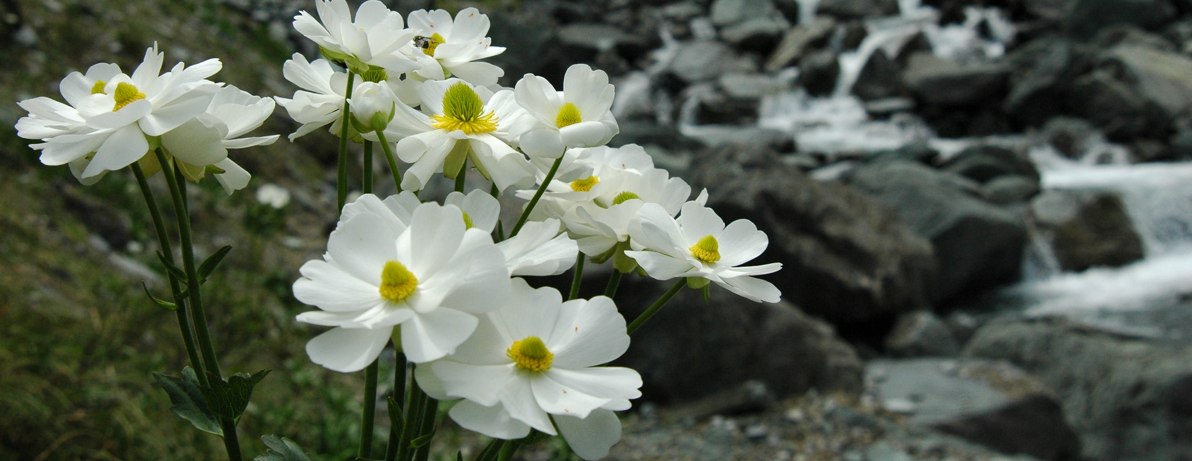
Since 1960 the NZ Alpine Garden Society has drawn members from all corners of the globe. Members range from the enthusiastic to the professional with interests covering miniature bulbs, rare perennials, shrubs and the full spectrum of alpine and rock garden plants.
Benefits of joining the Society
Seed Exchange 40,000 envelopes of seed covering 3,00 different species and varieties
Spring Show A highlight of our year. This year held on 12 and 13 September at a new exciting venue - the West Melton Community Centre. Many rare and desirable plants for sale, free parking, food and more
Meetings, Lectures, Workshops and Fieldtrips
Meetings are held on the 1st Thursday of each month (with occasional variations, check our website), Philatelic Centre, 67 Mandeville Street 8pm, doors open with plant sales at 7.30pm
Bulletin, Library and Newsletters Quality magazines each year
Volunteer Work to assist the development and maintenance of the Christchurch Botanic Gardens Crevice and Rock Garden area.

Subs
Single and Family NZ $36 E-sub $31 Over 65 $34 E-sub $29

Apply online or for more information www.nzags.com

